
REVERSE LOGISTICS ADVISORY
The Returns
Imperative
Why Every Ecommerce Retailer Needs a Deliberate Returns Strategy
Whether You Accept Returns Today or Not
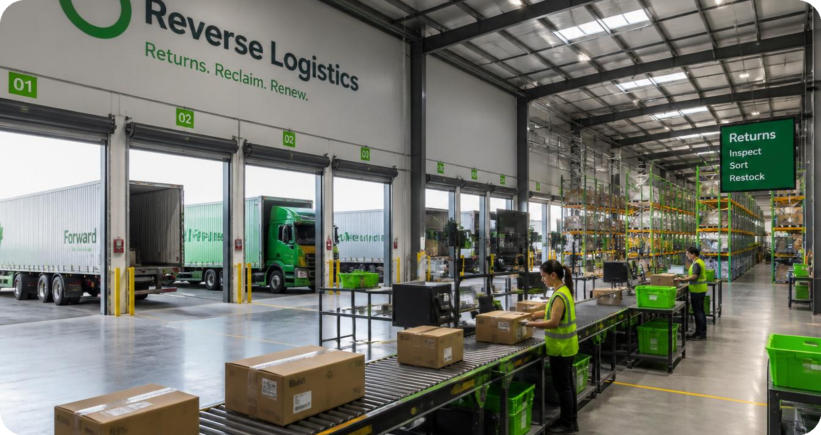
A VERTISTICS WHITE PAPER | vertistics.com

EXECUTIVE SUMMARY
Returns deserve deliberate design
Returns are not a back office detail anymore. They influence whether a shopper buys, how much profit remains after the sale, how quickly inventory can be recovered, and whether that customer comes back.
For many ecommerce retailers, the problem shows up in one of two ways. Some refuse returns because the policy appears to protect margin. Others accept returns but treat the process as a routine expense rather than a part of the business that can be improved. Both approaches create costs that are easy to miss.
A strict policy can discourage a customer before the order is placed. An unmanaged program can drain margin after the order comes back through extra handling, slow inspection, avoidable transportation, weak fraud controls, and poor decisions about resale or liquidation.
The business case is straightforward. Returns deserve the same deliberate design applied to forward fulfillment, customer acquisition, and inventory planning. This paper explains why that matters, what a capable returns program looks like, and where retailers can begin.
19.3%  of online sales were expected to be returned in 2025 | 82%  of consumers say free returns matter when shopping online | 71%  are less likely to shop with a retailer again after a poor returns experience

Source: National Retail Federation and Happy Returns, 2025 Retail Returns Landscape. [1]
SECTION 1
Returns Have Become a Material Business Issue
Online retail returns are now large enough to demand executive attention. The National Retail Federation and Happy Returns projected that retailers would receive $849.9 billion in merchandise returns during 2025. They also estimated that 19.3 percent of online sales would be returned. [1]
The financial impact reaches well beyond the refund. A returned item may require transportation, intake, inspection, grading, repackaging, customer service, inventory updates, and a decision about what happens next. The longer that decision takes, the less likely the product is to return to stock at full value.
That pressure is especially visible in categories where fit, preference, seasonality, or product condition matter. Apparel, footwear, consumer electronics, home goods, and beauty products may face very different return patterns, but the underlying questions are the same. What caused the return? How much will it cost to process? How quickly can the item be recovered? What is the best next channel for it?
Those questions connect returns to conversion, unit economics, inventory productivity, customer loyalty, fraud, and sustainability. When no one owns the full process, each team sees only part of the cost. Finance sees refunds. Operations sees labor. Customer service sees complaints. Merchandising sees aging inventory. Leadership needs the complete picture.
“Returns are not one isolated expense. They are a connected business system, and every delay or weak handoff reduces the value a retailer can recover.”

SECTION 2
The Same Problem Appears in Two Different Ways
Retailers usually recognize themselves in one of two situations. The first group does not accept returns, or allows them only in narrow circumstances. The second group has a policy and a working process, but little visibility into how well that process performs.
2.1 When the Policy Says No Returns
A no returns policy can look like a simple margin defense. There is no prepaid label, no restocking work, and no returned unit to manage. The problem is that the cost moves to an earlier point in the customer journey.
Online shoppers cannot handle, try on, or test a product before purchase. The return policy helps replace some of that missing confidence. When the policy feels risky, customers hesitate. Some leave the site. Others choose a larger competitor with a clearer and more forgiving process.
The 2025 Retail Returns Landscape found that 82 percent of consumers consider free returns important when shopping online. [1] Separate findings from Happy Returns show that 46 percent of shoppers have abandoned a purchase because convenient return methods were not available. [2] A strict policy may prevent some return expense, but it can also suppress orders that never appear in the sales data.
There is a trust issue as well. First time buyers are being asked to take a chance on the product, the brand, and the fulfillment experience. If the retailer offers no reasonable path when the purchase does not work out, the customer carries nearly all the risk. That is a difficult position for an emerging brand that is still earning confidence.
A retailer does not need to copy the most generous policy in the market. It does need a policy that fits the category, the product margin, and the customer promise. Clear rules and thoughtful exceptions often protect the business better than a blanket refusal.
2.2 When Returns Are Accepted but Not Managed
The second situation is more common. The retailer accepts returns, provides a label, and issues refunds. From the customer side, the basic process exists. Inside the business, however, the operation may still lack ownership, measures, and a consistent recovery plan.
That is where margin begins to leak. Returned units sit too long before inspection. Items that could be restocked are marked down because the selling window has narrowed. Products are sent to a liquidation channel by default. Return reasons are captured as vague notes, if they are captured at all. Fraud controls depend on individual judgment instead of consistent rules.
A working returns process is not the same as a managed returns program. A managed program can answer practical questions with data.
Management question | Why it matters
Which products are returned most often, and why? | Reveals issues in fit, quality, product content, or customer expectations
How long does each return take to reach a final decision? | Shows where inventory value is being lost through delay
What does each return cost by product and channel? | Makes the real impact on margin visible
How much value is recovered through each disposition path? | Measures whether recovery decisions are working
Which behaviors suggest fraud or policy abuse? | Supports targeted controls without making every customer experience harder

Fraud deserves particular attention. The National Retail Federation and Happy Returns reported that 9 percent of all returns in their 2025 study were fraudulent. [1] The right response is not a needlessly difficult policy for every shopper. It is better data, clearer rules, and controls that respond to actual risk.
SECTION 3
Returns Can Support Growth When the Operation Is Designed Well
A strong returns program does more than reduce cost. It gives customers enough confidence to buy, then protects the retailer when a product comes back.
That begins with the purchase decision. A clear policy removes uncertainty. Convenient options reduce friction. Fast communication reassures the customer that the process is moving. These details matter because 71 percent of consumers say a poor returns experience makes them less likely to shop with that retailer again. [1]
The operational side matters just as much. A return that is inspected quickly can be restocked while demand is still active. A product that needs light repair can move into a refurbishment path. An item that no longer belongs in primary inventory can be routed to a secondary channel that preserves more value than immediate liquidation.
The best outcome will not be the same for every unit. That is why disposition should be a decision, not a default. The goal is to choose the highest value responsible path based on condition, demand, season, handling cost, and channel requirements.
A capable program also creates useful feedback. If one size is returned repeatedly, the issue may be the fit guide. If customers say the item was not as described, the product page may need better photography or clearer specifications. If damage is concentrated in one shipping lane, packaging or carrier handling may be the real cause.
“Returns data can help prevent the next return. That is where the program begins to influence growth rather than simply process refunds.”

SECTION 4
Five Elements of a Strong Returns Program
Every retailer will make different policy and operating choices. Even so, effective programs usually share five elements.
01 | Policy Design  Make the policy easy to find, easy to understand, and realistic for the business. Customers need clear answers about timing, product condition, refund methods, exchanges, and fees.
02 | Operational Execution  Design intake, inspection, grading, and routing for reverse flow. Assign owners, measure service levels, and resolve exceptions before delay reduces inventory value.
03 | Technology and Data  Connect customer requests, reason codes, inventory status, fraud signals, and final disposition. Start with reliable information that people can use.
04 | Recovery and Disposition  Give every returned unit a defined path based on condition, demand, cost, compliance, customer commitments, and environmental impact.
05 | Continuous Improvement  Use return activity to improve product quality, merchandising, content, operations, and leadership decisions.

Vertistics evaluates these elements through a maturity lens. Some retailers are still defining a workable policy. Others have a stable operation but limited visibility. More advanced programs use return data to improve product decisions, reduce avoidable volume, and recover more value from what comes back.
SECTION 5
A Practical Starting Point
The right first step is not the same for every retailer. A business with no formal policy has a different challenge from a business processing thousands of returns each week. Both can begin with a focused review of the current state.
A useful assessment should establish four things.
Area | What to establish
Customer experience | Whether the policy and process give customers confidence without creating unnecessary exposure
Economics | The true cost of returns by product, reason, channel, and outcome
Operations | Where delays, rework, and inconsistent decisions reduce recovery
Data and governance | Whether the business has reliable information, clear ownership, and measures that support action

From there, leadership can prioritize the changes that will matter most. For one retailer, the answer may be a redesigned policy. For another, it may be faster inspection, better reason codes, new resale channels, or stronger fraud controls. The point is to solve the largest source of lost value first rather than launch a broad transformation without a clear business case.
SECTION 6
The Cost of Waiting
Return pressure is not likely to disappear. Consumer expectations are well established, and ecommerce volume continues to expose weaknesses that were easier to overlook at a smaller scale.
For retailers that refuse returns, waiting can mean continued conversion loss and slower trust building. For retailers with an unmanaged process, waiting means more inventory value lost through delay, more labor spent on rework, and less visibility into why customers are sending products back.
There is also an organizational cost. Once workarounds become routine, they are harder to unwind. Teams create their own spreadsheets, exception rules, and manual handoffs. The operation may continue to function, but it becomes more expensive and less consistent as volume grows.
A deliberate returns strategy does not require a massive project at the outset. It requires clear ownership, an honest view of current performance, and a practical sequence of improvements.
CONCLUSION
Turn Returns Into Results
Returns are part of the customer promise and part of the profit equation. Treating them as an afterthought leaves too much value exposed.
A retailer that does not accept returns should understand the effect of that choice on conversion and trust. A retailer that already accepts returns should know what the program costs, how quickly inventory is recovered, which products are creating avoidable volume, and where fraud or weak disposition decisions are reducing margin.
The opportunity is not to make every return disappear. It is to build a system that gives customers confidence, protects the business, and recovers as much value as possible.
Vertistics works with apparel brands, ecommerce companies, and retailers to assess current performance and build practical improvements across policy, operations, technology, and recovery. The work can begin with a new returns program or with a focused redesign of an operation already in place.
READY TO SEE WHERE YOUR RETURNS PROGRAM STANDS?
Start with a Returns Leak Audit
Benchmark the current program, identify the most important sources of lost value, and define the next practical step.
Visit vertistics.com
REFERENCES
Sources
[1] National Retail Federation and Happy Returns. 2025 Retail Returns Landscape. October 15, 2025.
[2] Happy Returns. 2025 Retail Returns Landscape Report Highlights.
Industry benchmarks describe broad market patterns. Actual performance will vary by category, product mix, policy, customer base, and operating model.

